Computer Programming Using Python 2.7 - Console 3 - Strings + Combining Strings, Python Indentation
GOALS: Combine strings; learn how indentation can make lines depend on the line above them if that line is conditional.
The teacher will explain the importance of putting spaces in literals, and of indentation in python.
Python indents are normally 4 spaces, and all of them must match (not like notepad, which uses a special character called a “hard tab” instead of spaces, which will not be considered matching a 4-space indentation even if it looks the same). In IDLE you can just push Tab key to create a 4-space indentation.
- Open IDLE, File, New Window
- File, Save As, Computer, H:, console3strings.py
- Type the following:
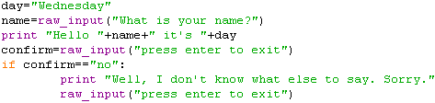

- Click Run, Run Module

